**Early Disease Detection Using Nail Image Processing**

**Mohammed Abdullah Al Mahfuz1, Kawsar Hossain1, Mahmuda Khatun2**

**1Student, Department of Computer Science and Engineering, Comilla University, Cumilla, Bangladesh.**

**2Assistant Professor, Department of Computer Science and Engineering, Comilla University, Cumilla., Bangladesh.**

**INTRODUCTION:**

The field of medical science has created numerous methods for diagnosing diseases in the human body. Among various indicators, nails are one of the ones that may be used to determine a person's health. When a person is sick, the symptoms will initially show up on their nails. Many diseases and conditions may be diagnosed by observing a person's nail color and form. Distinct disorders will be indicated by distinct nail colors, such as pink nails, which are typically a sign of health. indications of anemia, heart failure, starvation, and liver dysfunction have faded pink nails. The presence of a white nail with dark borders can indicate serious liver damage, such as hepatitis. A fungus infection is indicated by the color yellow. The nail thickens and becomes more brittle as the infection increases. Yellow nails can occasionally be a sign of a serious illness like thyroiditis, lung disease, diabetes, or psoriasis. Blue nails can occur when there is a lack of oxygen. However, cardiac abnormalities or a lung infection like pneumonia may also be to blame. Early psoriasis or arthritis symptoms include a corrugated nail surface. It's also usual to meet nail issues that cause the color to alter to red-brown. The most severe form of skin cancer, melanoma, will show symptoms if a longitudinal black stripe is seen in the center [1].

In order to address the preceding problem, we are developing a model for use in the diagnosis and treatment of nail disorders at their earliest stages. The diagnosis of nail illnesses is often based on a variety of characteristics, such as color, form, texture, etc. Here, one can take an image of a nail, and the image will be uploaded to a skilled model. The model analyzes the image to identify the degree of nail disease.

**MOTIVATION:**

The goal of the project "Early Disease Detection Using Nail Image Processing" is to employ advances in image processing methods to examine nail images in order to identify potential health issues at an early stage. This strategy takes care of the requirement for rapid and precise disease diagnosis. The initiative uses nails as a diagnostic tool in an effort to find anomalies that could point to underlying medical issues before outward symptoms develop. Compared to conventional diagnostic techniques, this non-invasive approach is more widely available and less expensive. Early detection enables quick prevention and intervention, lowering morbidity rates and the strain on healthcare systems. The study also makes use of recent developments in machine learning, computer vision, and image processing to create a precise and effective approach for spotting early disease using nail photos.

**OBJECTIVES:**

The primary objectives of the project is to create a system that can analyze photos of nails to find potential health issues or diseases. The project's goals include creating a comprehensive nail image database, creating a classification model, identifying disease-specific markers, assessing system performance, validating effectiveness through clinical trials, improving usability and accessibility, and encouraging awareness and adoption. The goal of the project is to further the development of a precise, non-invasive, and affordable method for leveraging nail image processing technology to identify various health issues in their early stages.

**LITERATURE REVIEW:**

Trupti S. Indi (2016) et al., in his paper proposed a method for detecting Early Stage Disease of Nail. Using the Weka utility, patients' nail images with maladies are used to generate training set data for neural network implementation [2].

In paper [3] proposed system that uses open CV to create a training set of nail color variations for disease identification. The trained dataset includes photos of people with specific conditions. There is an average 65 percent consistency with the data in the training set.

V.Saranya (2017) et al., In this study, popular unsupervised image segmentation methods including Watershed, Thresholding, and K-means are applied to digital photographs of fingernails. Shape characteristics are retrieved to identify nail disorders. With the use of feature extraction, the measured dimensions of these shapes may be determined. Comparing and analyzing the results for further use in nail disease diagnosis [4].

In [5], This work discusses nail feature classification approaches in a generalized model for human fingernail image processing systems. Color, shape, and texture indicate illnesses. The models SVM, KNN, and ANN categorize nail databases for illness prediction.

Vipra Sharma (2016) et al., suggested approach compares nail color and texture to a preset healthy nail value. It separates certain items using picture segmentation and then identifies the divided region for health evaluation [6].

The study [7] addresses four nail diseases: healthy, hyperpigmentation, clubbing, and fungus. Five deep Convolutional Neural Network models classify images, with accuracies of 92.5%, 87.5%, and 93.98%, respectively.

In paper [8], we explore disease detection using human finger nail images and analyze data based on color and texture. The methodology involves image segmentation, separating the shiny or glossy nail portion, and dividing the image pixels into homogenous regions.

Priya Maniyan (2018) et al., The Nail Image Processing System using KNN (NIPS-K) analyzes human nails, extracting color, shape, and texture features for disease prediction [9].

**METHODOLOGY:**

Nail image processing for early disease diagnosis has numerous phases. This section describes the nail image-based illness categorization method. Figure 1. describes the process briefly.

Datasets

Fine-tuning Model

Pre-trained Model

Data Preprocessing

Dataset

collection

Result Evaluation

**Figure 1.** Proposed System Architecture

A. Dataset Collection:

High-resolution nail photos of people with varied health issues are gathered from kaggle1 have 17 unique classes. This dataset supports algorithm training and testing. Figure 2. shows an infected nail.

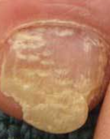

**Figure 2.** Infected Nail Image

3https://www.kaggle.com/datasets/jhoncris/nail-image

B. Preprocessing:

A series of preprocessing steps are performed on the nail pictures in order to improve their quality and maintain their uniformity before any further analysis is performed. Methods such as scaling, normalizing, noise reduction, and color correction may be included in this category. Their purpose is to verify that all of the samples are the same. Finally, we applied an 80:20 split between the train and test sets to the data. A summary of the dataset's classes is provided in Table 1.

**Table 1.** Explanation of Datasets

|  |  |  |
| --- | --- | --- |
| **Classes** | **Train** | **Test** |
| aloperia areata | 47 | 15 |
| beau_s lines | 42 | 8 |
| bluish nail | 50 | 13 |
| clubbing | 40 | 12 |
| Darier_s disease | 47 | 17 |
| eczema | 45 | 12 |
| half and half nailes (Lindsay_s nails) | 38 | 15 |
| koilonychia | 38 | 8 |
| leukonychia | 31 | 6 |
| Muehrck-e_s lines | 33 | 9 |
| onycholycis | 50 | 12 |
| pale nail | 35 | 8 |
| red lunula | 15 | 15 |
| splinter hemmorrage | 62 | 10 |
| terry_s nail | 36 | 9 |
| white nail | 19 | 6 |
| yellow nails | 27 | 8 |

C. Training Model:

After we had finished gathering data from Kaggle, we performed some preliminary processing on the data in order to get it ready for the transformer-based model. Following that, we started the Vgg16 model using a pre-trained model and then used the data we had acquired to fine-tune the model. In the end, we performed an analysis of the model using a variety of metrics.

D. Model Evaluation:

The performance of the produced model is assessed using relevant evaluation metrics such as accuracy, sensitivity, precision, and recall rates attained by cross-validation procedures or hold-out validation sets. The effectiveness of the designed model is evaluated using these indicators.

**Proposed Model:**



**Figure 3.** Vgg16 model4

4 [Keras-Implementation-of-VGG16-Architecture-2.jpg (861×225) (machinelearningknowledge.ai)](https://machinelearningknowledge.ai/wp-content/uploads/2020/08/Keras-Implementation-of-VGG16-Architecture-2.jpg)

The VGG-16 network is a subtype of the VGG Net. An RGB picture with a dimension of exactly 244 by 244 pixels serves as the VGG-16's input. During the pre-processing step, the RGB value of each pixel in a photograph is subtracted from its mean value. After the preliminary processing has been finished, Convolutional layers with 33-pixel-wide receptive-field filters are used to process the pictures. In certain configurations, the filter size is given the values (1 1), which indicates that the input channels have undergone linear transformation (which is then followed by non-linear transformation).

The path parameter of the convolution process has its default value set to 1. In order to perform the task of spatial pooling, After several convolutional layers, five maximally-pooling layers are utilized.5

5 <https://www.codingninjas.com/studio/library/vgg-16---cnn-model>

**Table 2.** No. of layers and size of input layers

|  |  |  |
| --- | --- | --- |
| Networks | Input layer size | No. of layers |
| Vgg16 | 224 × 224 | 16 |

**Table 3.** Equipment

|  |  |
| --- | --- |
| **Software and Hardware** | **Characteristics** |
| Processor | Intel Core i3, 2.2 GHz |
| Operating System | Windows 10, 64 Bit |
| RAM | 4 GB and above |

The layer count and input layer size for the model discussed in the preceding paragraph are summarized in Table 2. The CNN's training procedure is computationally intensive. Therefore, a 64-bit version of Microsoft Windows 10 is used for all of the tests, and the CPU is an Intel Core-i3 running at 2.2 GHz with 4 GB of RAM. All of this data is condensed for your convenience in Table 3. All of the instruction and evaluation is done on Google COLAB with the aid of the transfer learning tools. The user's nail images are received from the device and processed by the Vgg16 model to classify the wide variety of nail diseases. In conclusion, we present our findings via a web application that was developed utilizing the flask framework.

**EXPERIMENTAL RESULTS AND DISCUSSION:**

The VGG16 model obtained total 97.25% accuracy and 96.72% validation accuracy performing 50 epochs on datasets. The model's accuracy throughout training and validation is shown in Figure 4. Here, we can see that the accuracy in both training and validation greatly improved between epochs 1 and 40, and then stayed the same between epochs 40 and 50.

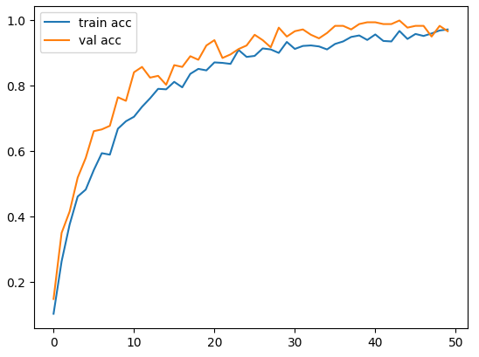

**Figure 4.** Training and Validation Accuracy

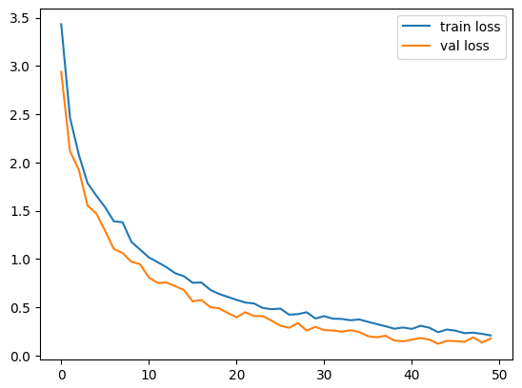

**Figure 5.** Training and Validation Loss

The model's loss throughout training and validation is shown in Figure 5. Here, we can see that both the training loss and the validation loss began dropping at a particular period.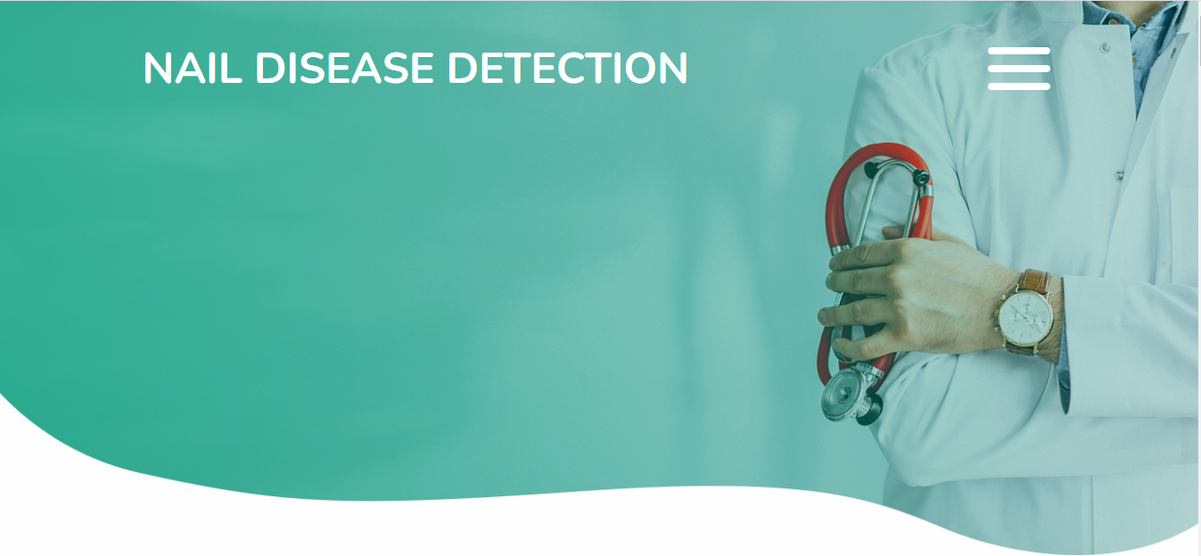

**Figure 6.** Home page of Web app

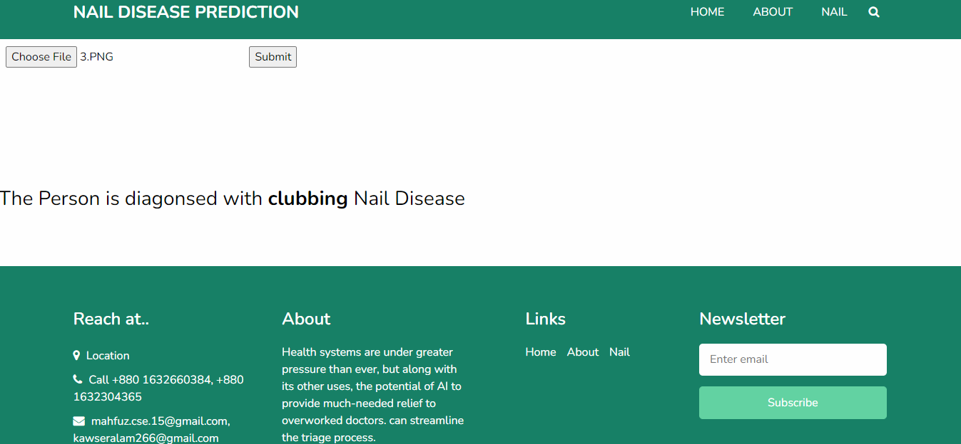

**Figure 7.** Output page of web app

**CONCLUSION:**

Our study implements a CNN-based Vgg16 model for early-stage illness detection in humans. Accuracy is the yardstick by which we judge the quality of our work. The suggested approach successfully predicted the illness with a high degree of accuracy. As was previously indicated, various disorders have been associated to noticeable changes in nail color. The model outperforms the human visual system because it is not hindered by factors like low resolution power and subjective evaluation. The findings may have clinical applications. Deep neural networks will be used in the near future to find more health problems in people.

**REFERENCES:**

*[1]., Saranya & Ranichitra, A.. (2017). IMAGE SEGMENTATION TECHNIQUES TO DETECT NAIL ABNORMALITIES. International Journal of Advanced Research. 8. 522-527.*

*[2] Indi, T. S., & Gunge, Y. A. (2016). Early stage disease diagnosis system using human nail image processing. IJ Information Technology and Computer Science, 7(7), 30-35.*

*[3] Venkataranganathan, A. V., Hariharan, R. J., & Roopa, M. (2022). A Noninvasive Diagnosis of Early Stage Diseases through human nail using Neural Networks. Journal of Artificial Intelligence, 4(1), 80-86.*

*[4] Saranya, V., & Ranichitra, A. (2017). Image segmentation techniques to detect nail abnormalities. Scholar, 2(1).*

*[5]* Indi, T. S., & Patil, D. D. (2019). Nail feature analysis and classification techniques for disease detection. *Int. J. Comput. Sci. Eng*, *7*(5), 1376-1383.

*[6]* Sharma, V., & Shrivastava, A. (2015). System for Disease detection by analyzing finger nails Color and Texture. *International Journal of Advanced Engineering Research and Science (IJAERS)*, *2*(10).

*[7]* Abdulhadi, J., Al-Dujaili, A., Humaidi, A. J., & Fadhel, M. A. R. (2021). Human nail diseases classification based on transfer learning. *ICIC Express Letters*, *15*(12), 1271-1282.

*[8]* Sharma, V., & Ramaiya, M. (2015). Nail color and texture analysis for disease detection. *International Journal of Bio-Science and Bio-Technology*, *7*(5), 351-358.

*[9]* Maniyan, P., & Shivakumar, B. L. (2018). Early Disease Detection Through Nail Image Processing Based On Ensemble Of KNN Classifier And Image Features. *IOSR Journal of Computer Engineering (IOSR-JCE)*, *20*(3).